Assignment 11 Low-information content languages

Before class Monday 12/2: read this document and make notes of any questions you might have.

Monday 12/2, Wednesday 12/4, and Friday 12/6: will be studio classes devoted to this assignment.

Monday 12/9: present your assignments

Friday 12/13: final version due during “exam time.”

In this assignment we will investigate the question of NP in terms of other notions of complexity. Recall (you may want to review Assignments 3-5) that NP describes languages whose membership can be decided by algorithms that run in nondeterministic polynomial time. In this assignment we will ask if there are “low-information” NP languages, according to different notions of “low information.”

Definition 1: P-selective.

A language 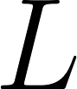 is said to be P-selective if there exists a (deterministic) polynomial time function 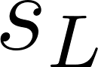 (called a selector function) that takes two strings as input 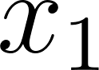 and 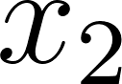 and returns one of them such that, if either  or 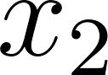 are in  then  returns the string that is in . If both  and  are in  or not in  then  may return either one (but it always returns the same one).

Question 1 (more to follow):

Prove the following Theorem:

Theorem P: if SAT is P-selective, then P = NP.

Proof.

Prove this through the following lemmas:

Lemma P1: If SAT is P-selective, then SAT is in P.

Proof:

Lemma P2: If SAT is in P, then P = NP

For this and Question 2 below, the concept of a many-one reduction is important (we have seen it before). Given two languages 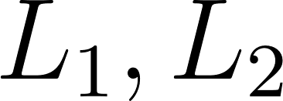, we say that 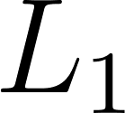 many-one reduces in polynomial time to 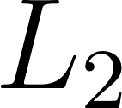 if there exists a polynomial time function 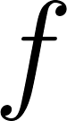 such that, for any string 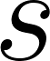, 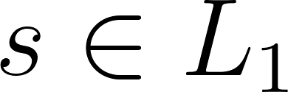 if and only if 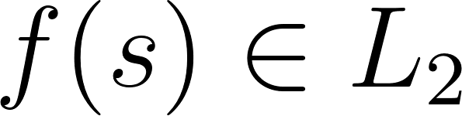.

Recall that the Cook-Levin theorem essentially states that every NP language is many-one reducible to SAT.

Proof:

Bonus Question:
Show that there is an uncomputable P-selective set.

Question two is based on another notion of “low-information:” We say a language is tally if it contains only one character. E.g., is a tally language, but 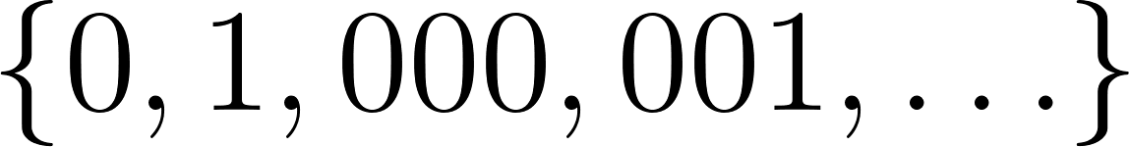 is not.

Question 2
Prove the following theorem.

Theorem P2 If SAT is many-one reducible in polynomial time to an NP tally set, then P = NP.

Proof:

